Name:
Before, After, During Thinking Guide
The Absolutely True Diary of a Part-Time Indian
Chapters 5-6
Before:
- Look through pages 32-47 and analyze the pictures. Make a prediction of what you think chapters 5-6 are about.

During:
Chapter 5- Hope Against Hope
- Fill in the cause and effect chart starting with events that happened from the chapter. The cause has been given to you from the text. Fill in the effect side. The first one has been completed for you. Fill in all boxes.
Cause | Effect
Junior- “So that means I was staring at a geometry book that was at least thirty years older than I was.” | Junior gets extremely angry because he realizes the textbooks are the same ones from when his parents were in school, he wonders how and why they are still learning from the same book.
Junior- “I wanted to hit something when I threw that ancient book”
Junior- “I was suspended from school after I smashed Mr.P in the face, even though it was a complete accident.”
Mr.P- “She wanted to write romance novels.”
Junior- “No teacher had ever said anything so nice, so incredibly nice, to me.”
Junior- “Other kids, they beat me up when I cry.”
Referring to Rowdy- “He came to school with a black eye.”

- Explain the following quotes from the chapter: “You can’t give up. You won’t give up. You threw that book in my face because somewhere inside you refuse to give up.”

- A Haiku is a three lined poem. The first line has 5 syllables. The second line has 7 syllables. The third line has 5 syllables.
Example:

Sherman Alexie (5 syllables: Sher-man-A-lex-ie)
Wrote a book about his life (7 syllables: Wrote-a-book-a-bout-his-life)
He went through a lot (5 syllables: He-went-through-a-lot)

Create four different Haiku poems. The Haikus will be from the point of view of the characters in the novel. Use the information you have read about the characters to create the Haiku. They should not be generic but extremely specific to the detail in the book.
Mr. P
Junior
Junior’s Parents

Mary Runs Away

- How did Mr.P change Junior’s view of his sister?

- Why did Mr.P insist that Junior leave the reservation?

Chapter 6- Go Means Go

- Write the positives and negatives to Junior leaving the reservation.

After:
- Go back to page 47 with the picture of Junior’s head on the anthill. Write your own interpretations of that picture. What does it symbolize? How does this picture summarize the last two chapters?

- In the boxes below, draw a prediction of what you think will happen to Junior if he transfers to Reardan. Draw one prediction in each box.

Chapters 7-8
Before:
Fill in the Somebody Wanted But So based on the previous chapter using only words!
Somebody (characters)…

Wanted (plot, motivation)…

But (conflict)…

So (resolution)…

During:
- Why did Rowdy flip out on Junior? How did his reaction carry out Mr.P’s prediction?

- Using the information from the novel, write a Sensory poem from Rowdy’s point of view. An example from Junior’s point of view has been provided for you.
Sensory Poem Format: Example Poem from Junior’s POV
Line 1: An emotion Line 1: Torn
Line 2: …sounds like Line 2: Sounds like Rowdy screaming/ Mr. P persuading
Line 3: …smells like Line 3: Smells like a breath of fresh air
Line 4: …tastes like Line 4: Tastes like blood dripping down my nose
Line 5: …looks like Line 5: Looks like white kids in my future
Line 6: … feels like Line 6: Feels like I lost my best friend

Rowdy

Line 1:
Line 2: Sounds like
Line 3: Smells like
Line 4: Tastes like
Line 5: Looks like
Line 6: Feels like

Chapter 8- How to Fight Monsters
- “You can’t just betray your tribe and then change your mind ten minutes later. I was on a one-way bridge. There was no way to turn around, even if I wanted to.” Based on this quote, what can the reader infer about Junior’s decision?

- Reread pages 55, when Junior gets dropped off by his father, to page 56, when the Reardan students start to show up. How does the tone change from page 55 to page 56?

- Fill in the split sided sketch of you below. On one side put words, symbols, and images that express how you see yourself. On the other side put words and images of the way others see you. Make sure to label symbols like is done in the novel.

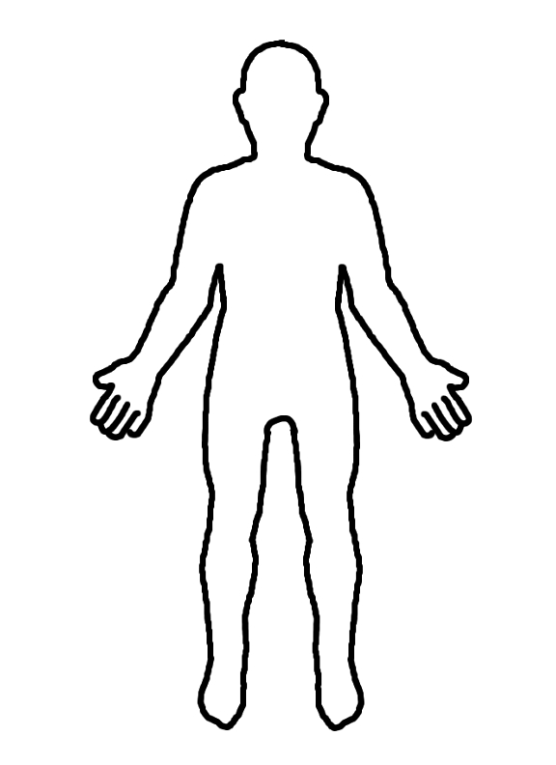
How I see myself
How others see me
Discussion Questions with a partner:
- How did Junior’s understanding of the rules of “Fisticuffs” lead to the incident with Roger?
- Why did Junior say “somebody had shoved me into a rocket ship and blasted me to a new planet. I was a freaking alien and there was absolutely no way to get home?”

After:

- Explain how the two setting in the novel have helped shape the plot of the story.

- Give an example from the novel of each type of conflict in the box.

Type of Conflict | Example
Person vs. Person

Person vs. Self

Person vs. Fate

